Help guide 5: How to view feedback from teachers on work completed
At the top of the General page within a subject Team, pupils are to click on Assignments. All of the assignments set for pupils will be in this area as well as a link to those completed. The teacher feedback will be done on the assignments completed.

Pupils are to click on the relevant assignment. This should be identified by the name and date. If a pupil has a new assignment then it is at the top and will be given a due date, and if a pupil has completed an assignment it goes into the bottom area under completed.

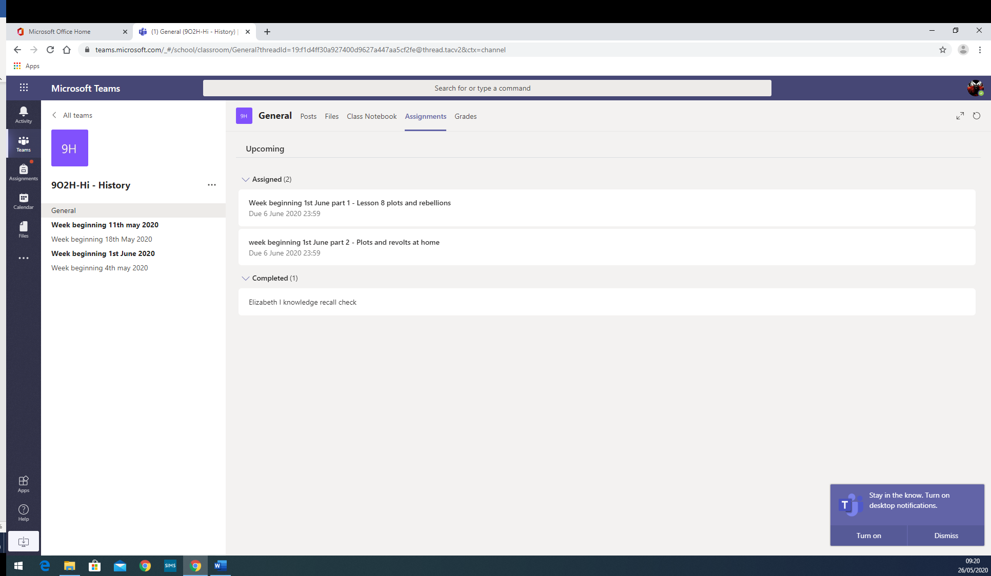

After a teacher has given feedback on the work they will return it to the pupil. If a pupil clicks on the completed assignment link their feedback for each assignment will be on the screen.

Pupils MUST then click ‘hand in’ in the top right hand corner for the work to be submitted to the teacher for feedback. If a pupil has not received feedback and you think they should have, please check that they have clicked ‘hand in’ when they have completed it.

