Patriarchy
Noun – a system, society or government where men hold the power

The patriarchy at the time meant that men dictated how women behaved.
Limerence
Noun – feelings of obsessive infatuation

Roemo’s limerence for Rosaline leads us to question if he truly loves Juliet.
Prologue/ Epilogue
Noun – section or introduction to literary work (Pro.)
Section or conclusion to literary work (Epi)
Shakespeare’s Prologue foreshadowed the events yet to take place.
Sonnet
Noun – romantic form of poetry; A Sonnet is a poem of an expressive thought or idea made up of 14 lines, each being 10 syllables long.
The sonnet form is used here to emphasise the foundations of love between Romeo and Juliet.
Antithesis
Noun - a person or thing that is the direct opposite of someone or something else.

The antithesis used reveals the battle between love and hate.
Emblematic
Adjective – something that is symbolic of a certain idea or concept

Romeo is emblematic of toxic masculinity in Veronese society.
Hamartia
Noun – fatal flaw which leads to the downfall of a character

Romeo’s unquestionable love, in the end, is his hamartia.
Tragedy
Noun – genre of a play dealing with tragic events, such as death, deception and downfall of main character
The events join to reinforce the genre of this Shakespearean tragedy.
Juxtaposition
Noun – two things being placed close together with contrasting effect

The light of the two lovers is a juxtaposition against the darkness of their fate.
Pilgrim
Noun – a person journeying to a sacred or religious place; to wander

Romeo’s name derives from the meaning ‘pilgrim to Rome’; he is on his pilgrimage for love.
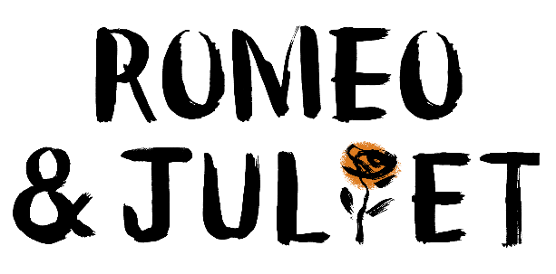
Misanthropic
Adjective – showing dislike of humankind; unsociable

Scrooge is a misanthropic miser.
Authorial intrusion
Noun – where the author penning the text speaks out to the reader

At this point the writer uses authorial intrusion to speak directly to the reader.
Motif
Noun – recurring idea or symbol in a text

The motif of light is used throughout the novella.
Benevolence
Noun (benevolent – adj.) – kindness; well meaning

The Ghost of Christmas Present is the epitome of benevolence.
Metamorphosis
Noun – change form

In Stave 5, we see the true extent of Scrooge’s metamorphosis.
Redemption
Noun – the act of saving or being saved from sin, error or evil

One of the key themes, redemption, emphasise to the reader that it’s never too late to change.
Foil
Noun – contrasting character to another

Bob Cratchit is the foil to Scrooge, showing differing opinions on family.
Allegory
Noun – a story, poem or picture that can be interpreted to reveal a hidden meaning

The novella is a religious allegory, where Dickens teaches us about the true meaning of Christmas.
Supernatural
Adjective/ Noun – manifestations or events deemed not to normally happen in the natural world

The ghosts represent the supernatural element to this Victorian story.
Symbolism/ Symbolic
Noun- the use of symbols to represent an idea

The throne of food is symbolic of surplus food; Dickens’ attack against Malthusian theory.
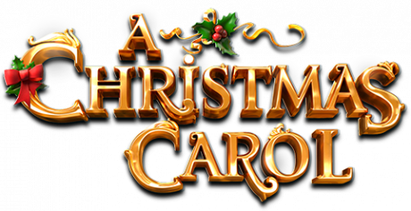
Socialism
Noun – a political and economic theory centred on sharing and community

Priestley uses his play to foreground the ideologies of Socialism.
Capitalism
Noun – a political and economic system centred on private trade and profits

Mr and Mrs Birling are personified examples of Capitalism.
Didactic
Adjective – intended to teach or share a moral

The didactic purpose of this play was that we all have collective responsibility for each other.
Bourgeoisie/ proletariat
Noun – the middle class, typically linked to materialism. Marxism – typically capitalist
Noun – the lower, working class
Eva Smith is a typical, proletariat female. The Birlings represent the Bourgeoisie.
Impoverished
Adjective – made poor

Eva Smith is impoverished by Sheila’s actions.
Superficial
Adjective – appearing to be true until examined more closely; false

Mr Birling is superficial in his actions; being more concerned about his knighthood that the common welfare of others.
Dramatic irony
Noun – where significant ideas linked to a character are clear to the audience though unknown to the character

This moment is an example of dramatic irony as…
Chronological
Noun – written or presented in order of time

The events of the play are chronological, led by the Inspector.
Playwright/ audience
Noun – writer of the play
Noun – read of the play
The playwright wants us to see that…. The audience would react here by…
Hierarchy
Noun – ranking or status of authority

The hierarchy of society meant there were huge class divisions in 1912.
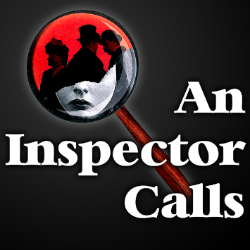
Imagery
Noun – when words paint a picture in our heads, so we can imagine it

The poet uses imagery here to fully emphasise how destructive war can be.
Voice
Noun – the ‘speaker’ in the text

Wordsworth’s voice in the poem shares the personal experiences he had on the boat.
Context
Noun – social, historical, cultural background information

Linking to the context, this reinforces how displaced emigrants can feel, even in the present day.
Volta
Noun – the turning point in a poem, when something shifts or changes

The writer uses a volta when… to shift the tone to more looming and dangerous.
Semantic Field
Noun – a category or group of words that are linked

The semantic field of weather highlights how dangerous war is, and how nature was attacking like an enemy.
Enjambment
Noun – when a line breaks, and moves onto the next line

Enjambment creates regular lines lengths, which in turn develops regular stanzas that reflect pieces of paper or a ‘paper trail’ of our lives..
Stanza
Noun – the verse or ‘paragraph’ of a poem

Exposure was written in regular stanzas to emphasise how each day was the repetitive and the same for the soldiers.
Refrain
Noun – a repeated line in a poem

Tennyson uses the refrain____ to create a rhythm, like beating horse shoes.
Caesura
Noun – a strong pause in the middle of a line of poetry

Caesura has purposely been used when… to force the reader to pause and think.
Ambiguity
Noun – when something is unclear or could be understood to mean more than one thing

The poet uses ambiguity to cause fear and confusion.
